**NO:** b22-23MQ113

**INVOICE**

**DATE:** 09/06/2022

**To,**

**IDS Technologies India Pvt. Ltd**

**Survey No. 344/2,**

**Opp- Nagshanti Hyundai Showroom,**

**Udyambag , Belgaum, Belgaum -590008**

**GST No - 29AACCI4824K1ZB**

**Po Number - IDST/JPT/22-23/054**

|  |  |  |  |  |
| --- | --- | --- | --- | --- |
| **Sr. No** | **Item Description** | **Qty** | **Price** | **Total** |
| 1 | 30 Ltrs Admixture Tank as per layout | 2 | 19000 | 38000 |
| **Total** | | | | **38000** |
| **IGST 18 %** | | | | **6840** |
| **Grand Total** | | | | **44840** |

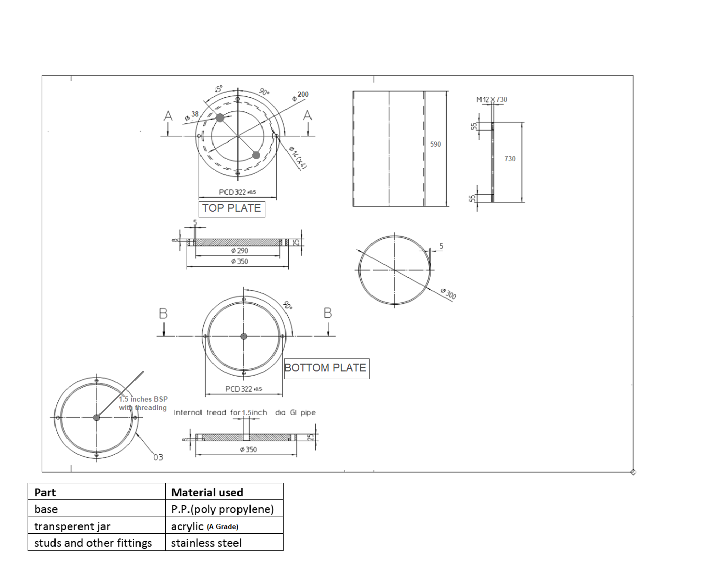

**Company’s Bank Details**

**Bank Name:** Central Bank of India

**Account Number:** 3167002097

**Branch & IFS Code:** Panaji & CBIN0280713

**Terms & conditions apply**

*Any physical defect to be checked and informed at the time of delivery itself will not be entertained thereafter.

Goods once sold cannot be returned or replaced

Supply item only.

Logistic charges to be charged as actuals.

No warranty guarantee.

Physical damage if any to be reported on the day of supply only.

**GOODS RECEIVED IN WITHOUT ANY DEFECTS**